[N2_L1_E1](https://github.com/jaidernperez/Introduction_Programing/blob/master/CodeGym/N2_L1_E1.PNG)

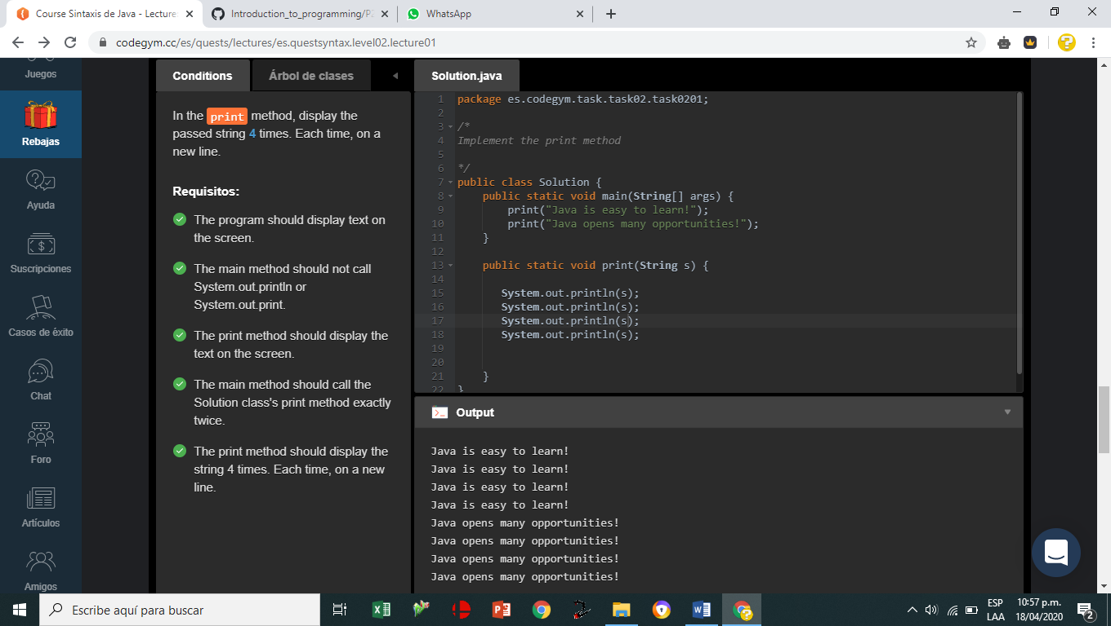

[N2_L2_E1](https://github.com/jaidernperez/Introduction_Programing/blob/master/CodeGym/N2_L2_E1.PNG)

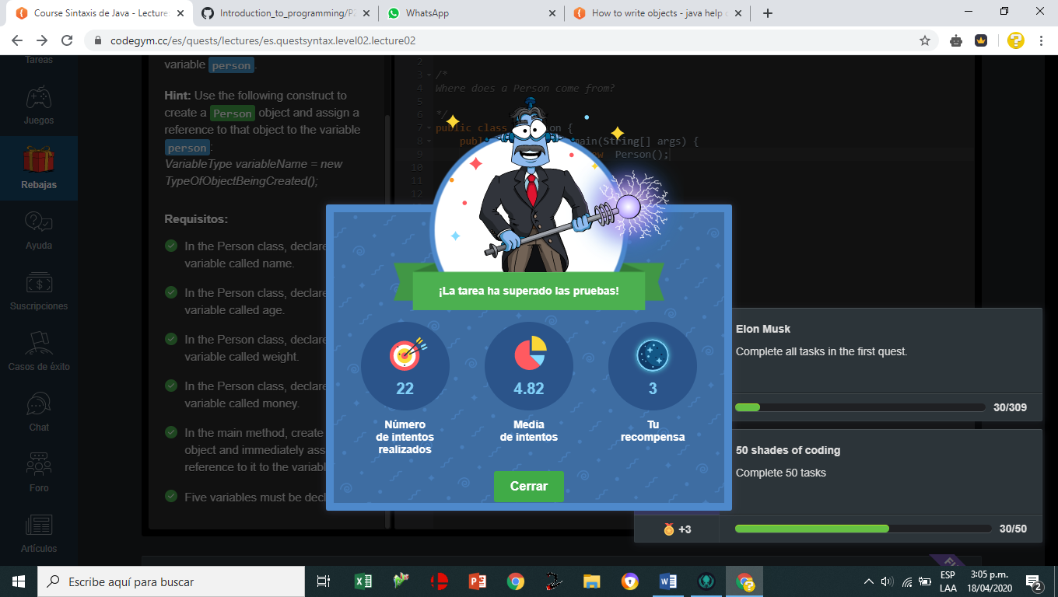

[N2_L2_E2](https://github.com/jaidernperez/Introduction_Programing/blob/master/CodeGym/N2_L2_E2.PNG)

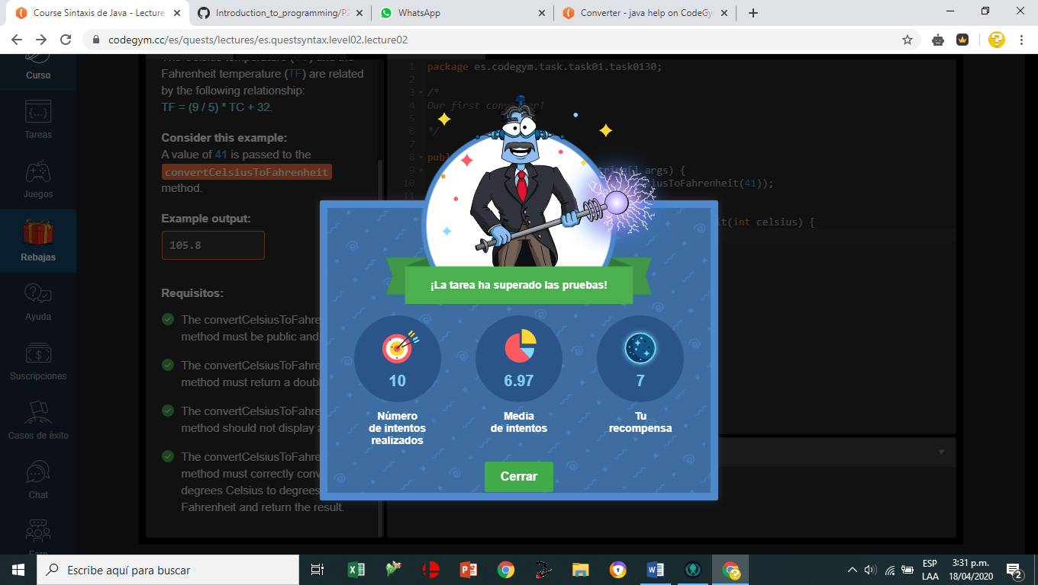

[N2_L2_E3](https://github.com/jaidernperez/Introduction_Programing/blob/master/CodeGym/N2_L2_E3.PNG)

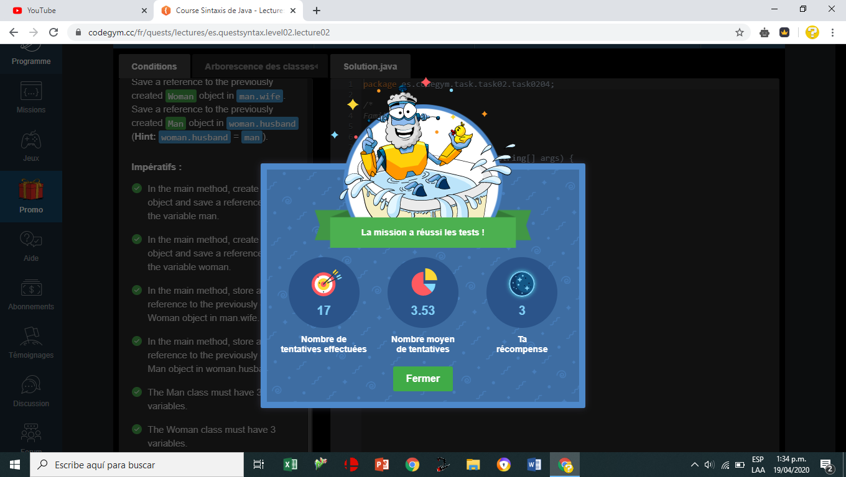

[N2_L2_E4](https://github.com/jaidernperez/Introduction_Programing/blob/master/CodeGym/N2_L2_E4.PNG)

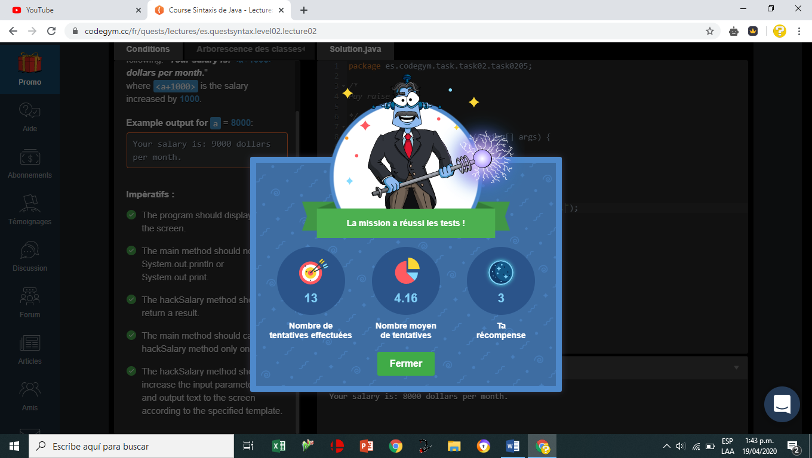

[N2_L2_E5](https://github.com/jaidernperez/Introduction_Programing/blob/master/CodeGym/N2_L2_E5.PNG)

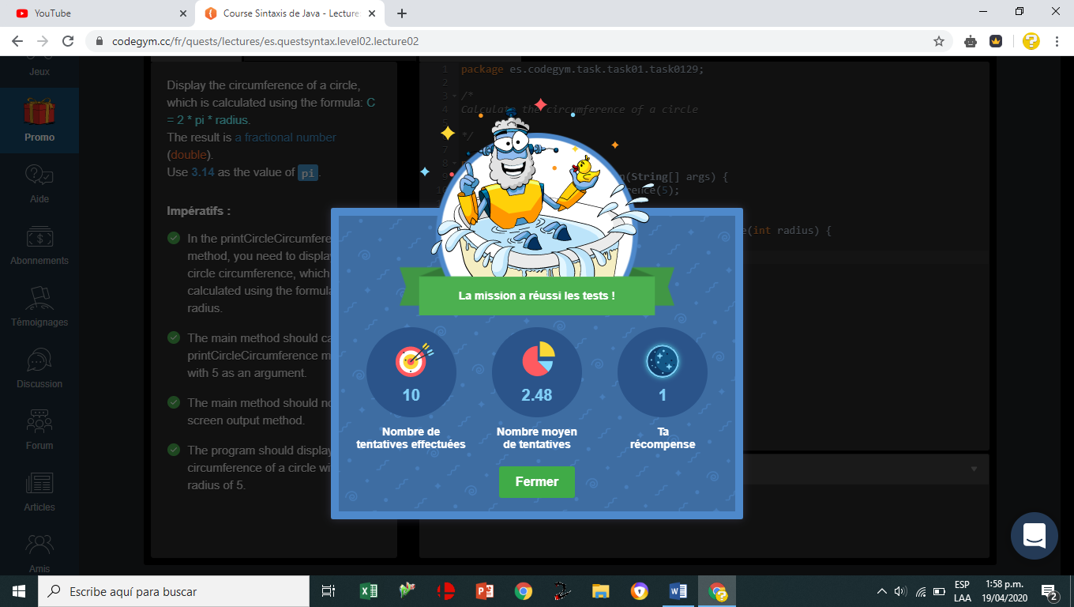

[N2_L2_E6](https://github.com/jaidernperez/Introduction_Programing/blob/master/CodeGym/N2_L2_E6.PNG)

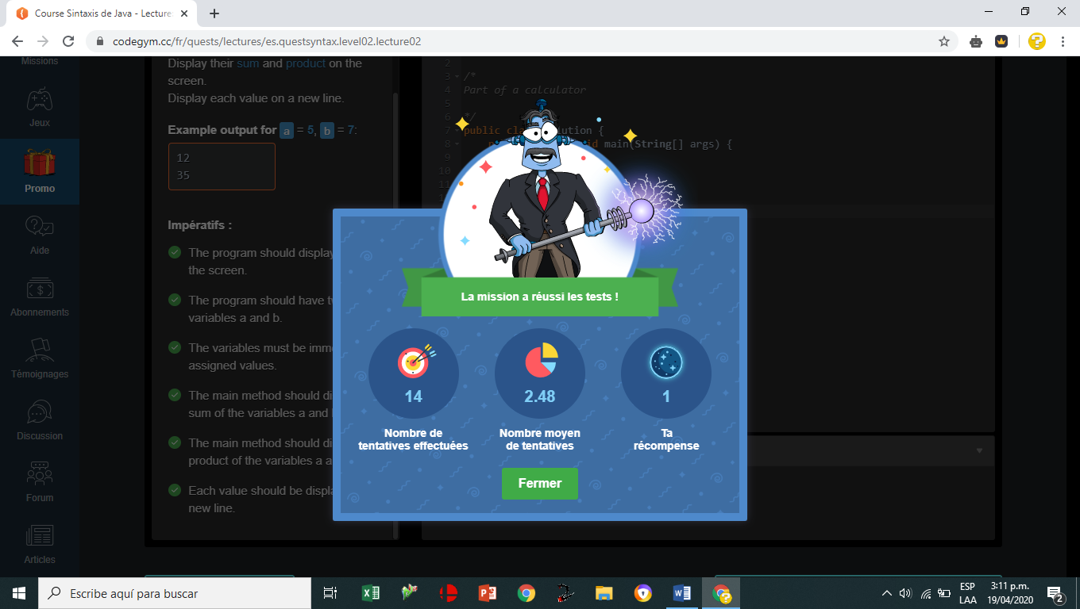

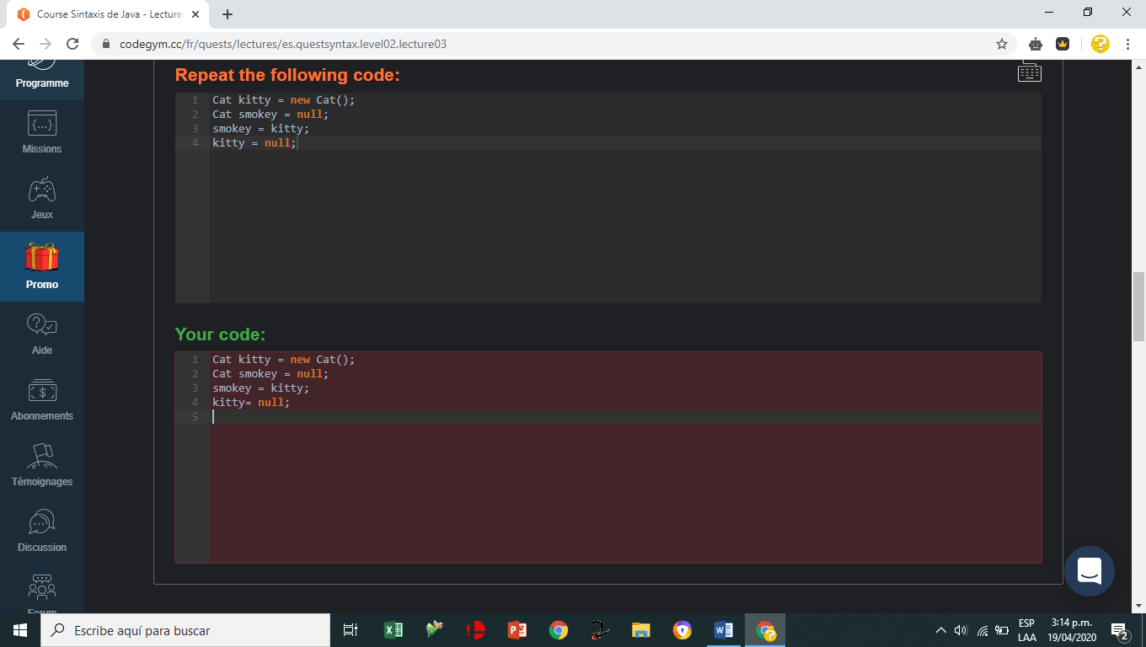

[N2_L3_E1](https://github.com/jaidernperez/Introduction_Programing/blob/master/CodeGym/N2_L3_E1.PNG)

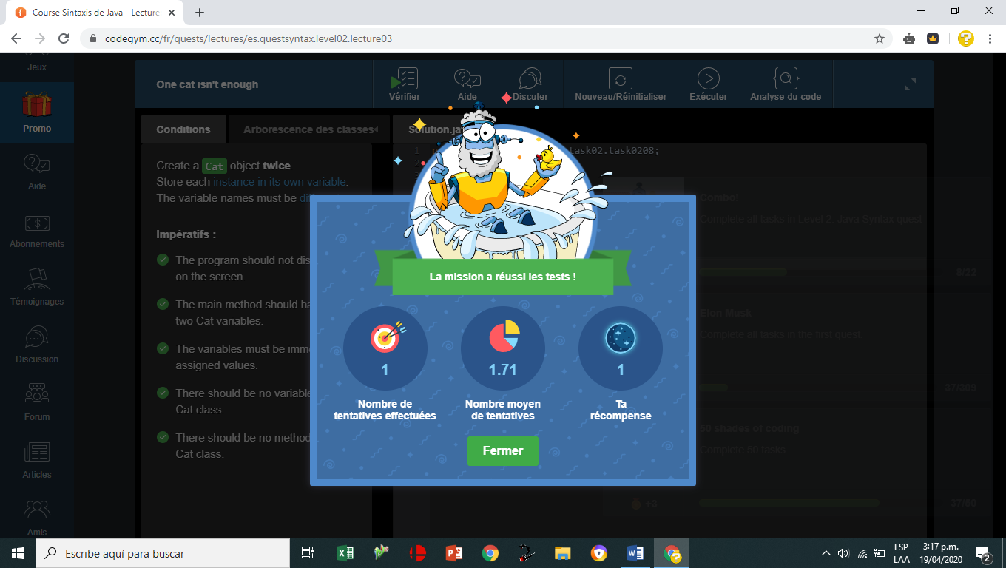

[N2_L3_E2](https://github.com/jaidernperez/Introduction_Programing/blob/master/CodeGym/N2_L3_E2.PNG)

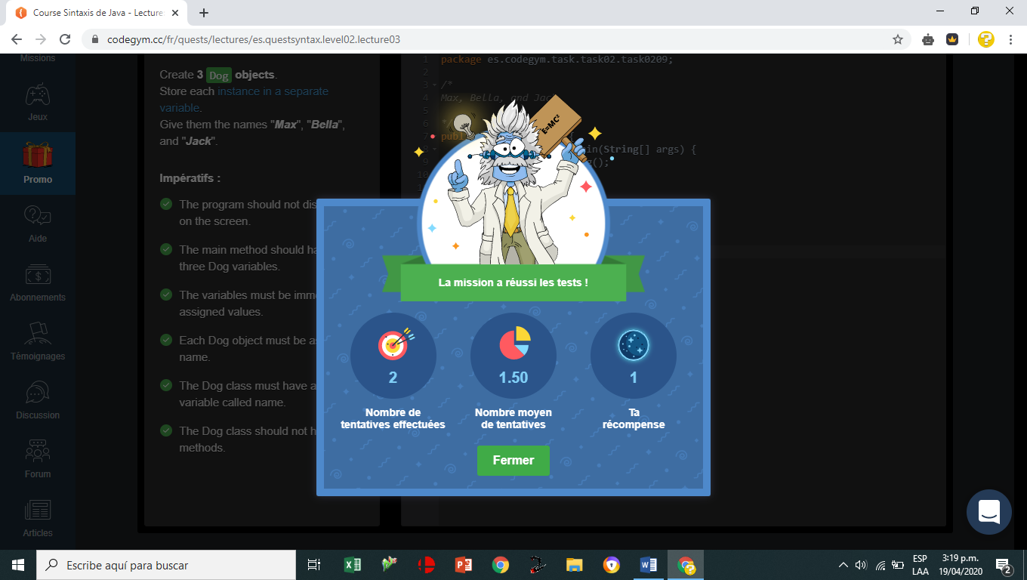

[N2_L3_E3](https://github.com/jaidernperez/Introduction_Programing/blob/master/CodeGym/N2_L3_E3.PNG)

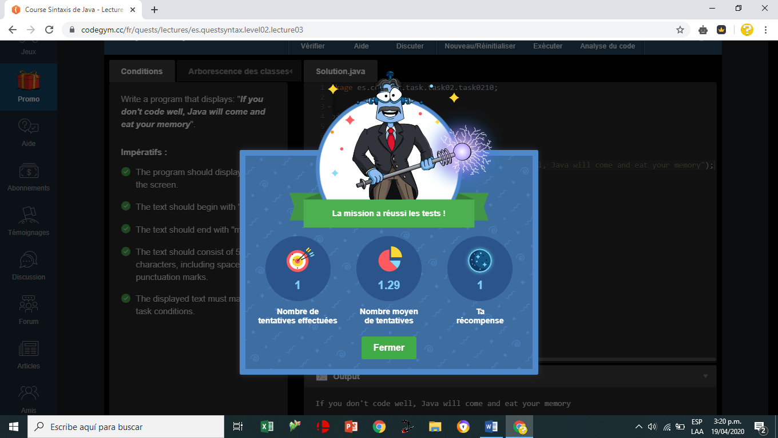

[N2_L5_E1](https://github.com/jaidernperez/Introduction_Programing/blob/master/CodeGym/N2_L5_E1.PNG)

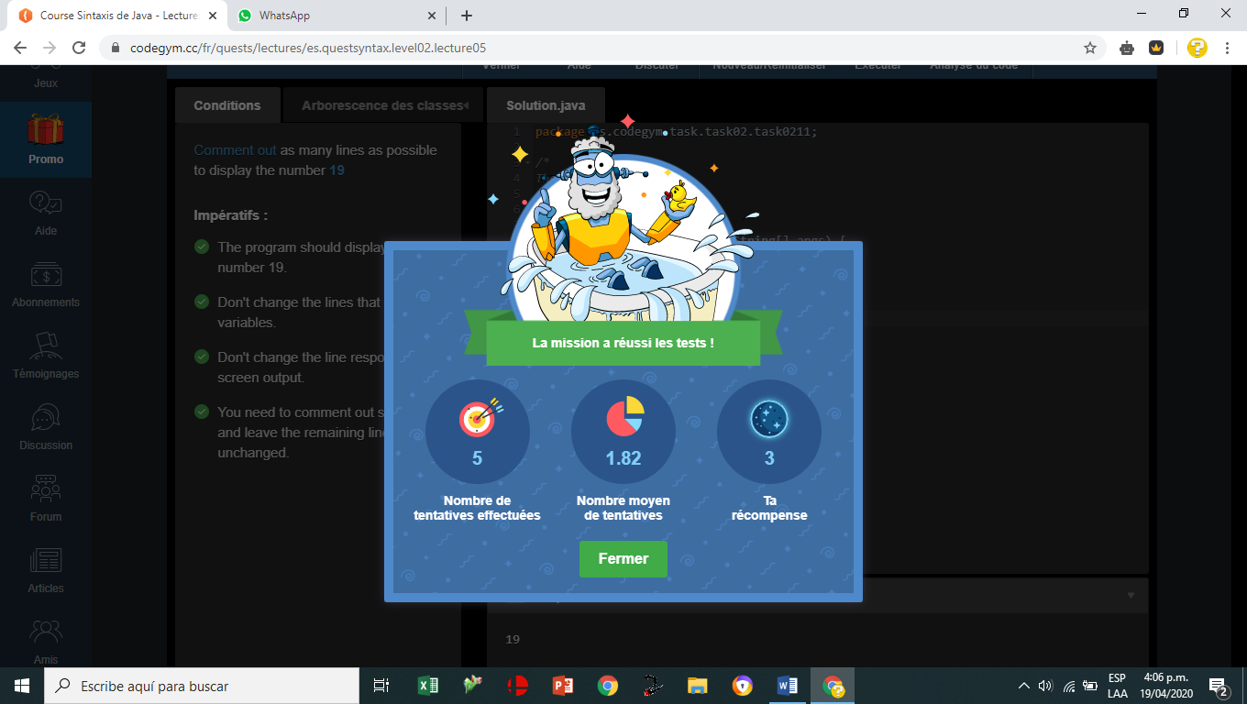

[N2_L5_E2](https://github.com/jaidernperez/Introduction_Programing/blob/master/CodeGym/N2_L5_E2.PNG)

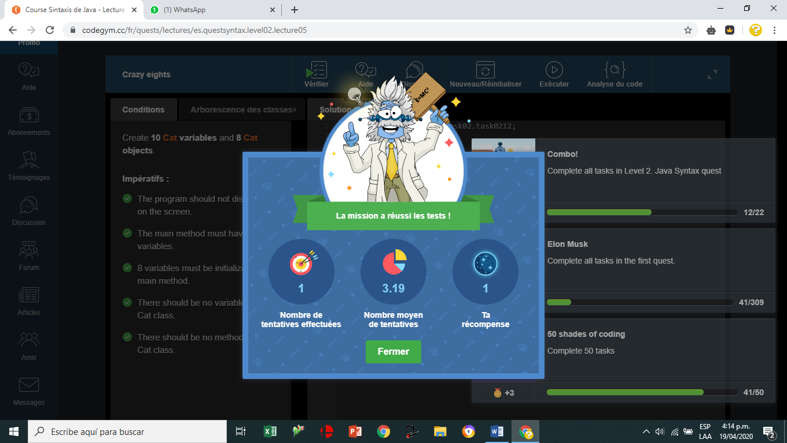

[N2_L5_E3](https://github.com/jaidernperez/Introduction_Programing/blob/master/CodeGym/N2_L5_E3.PNG)

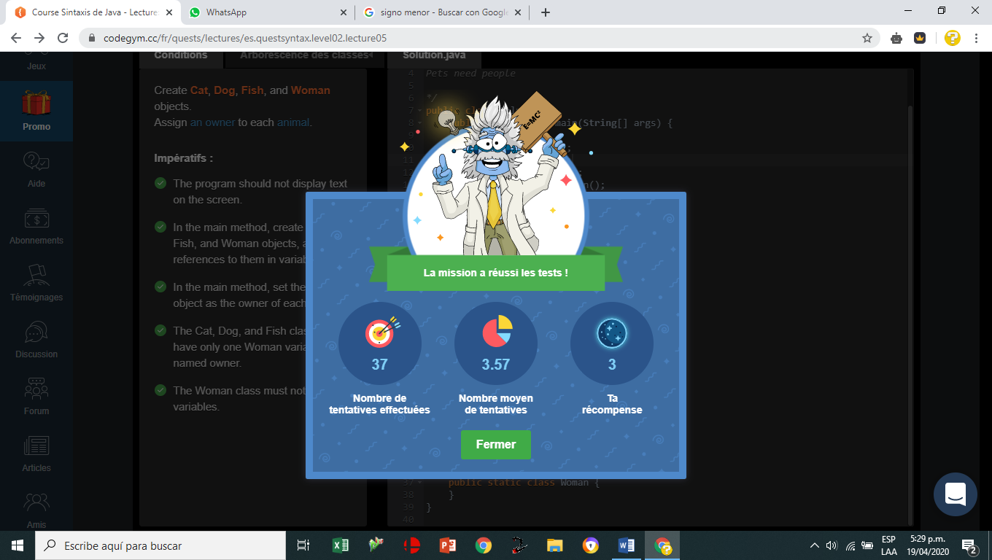

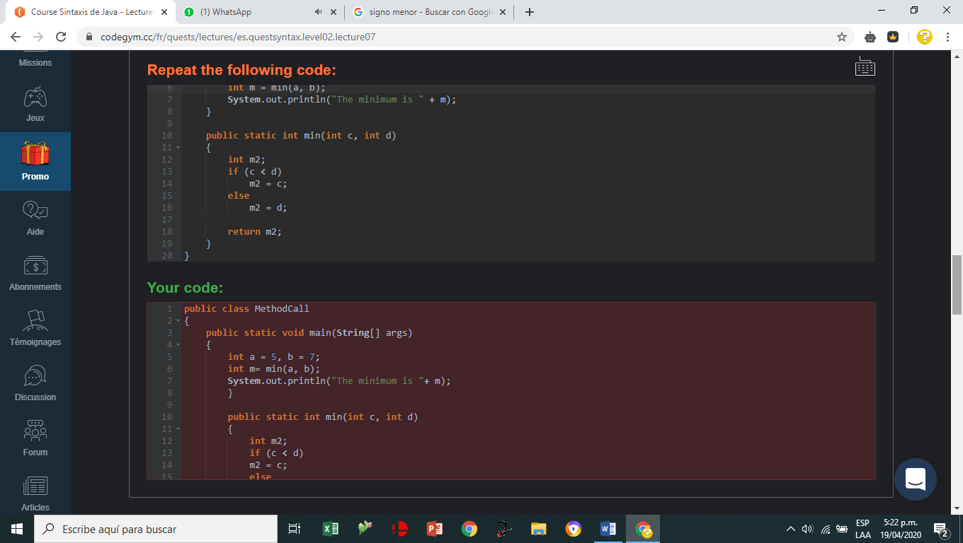

[N2_L8_E1](https://github.com/jaidernperez/Introduction_Programing/blob/master/CodeGym/N2_L8_E1.PNG)

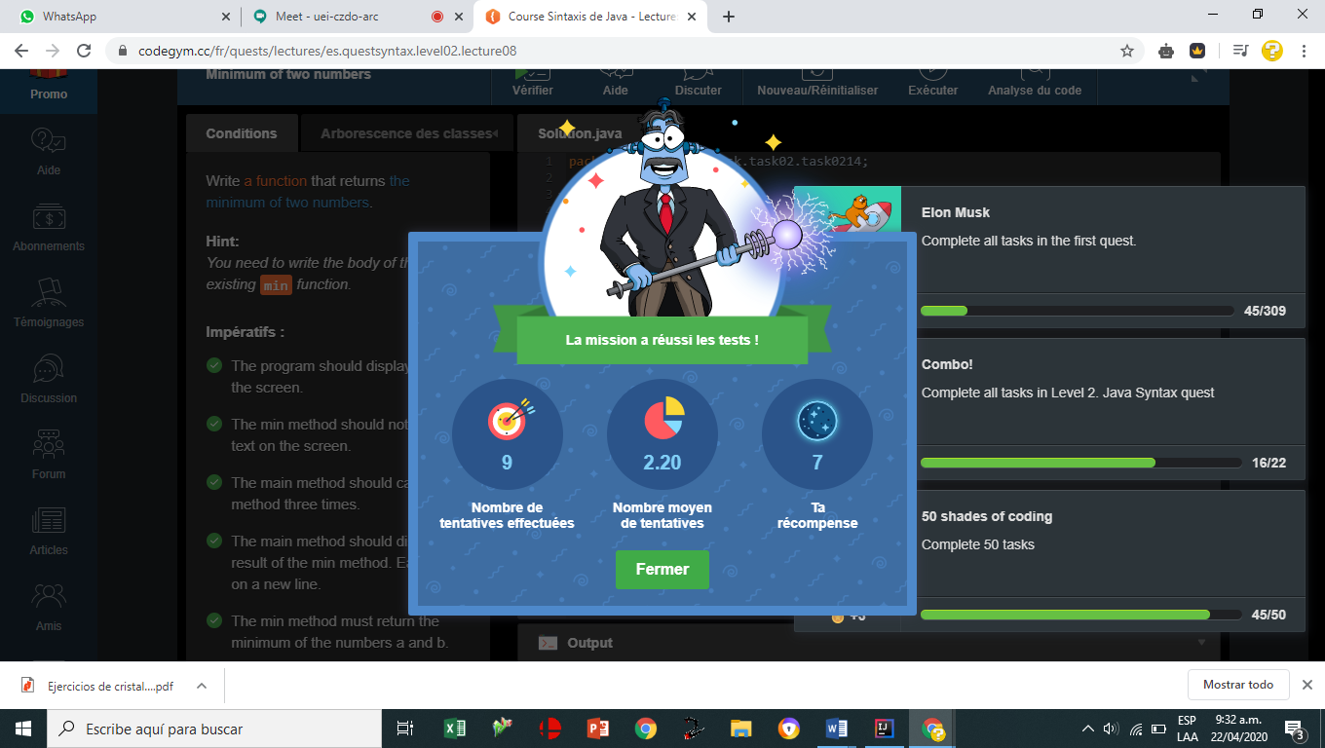

[N2_L8_E2](https://github.com/jaidernperez/Introduction_Programing/blob/master/CodeGym/N2_L8_E2.PNG)

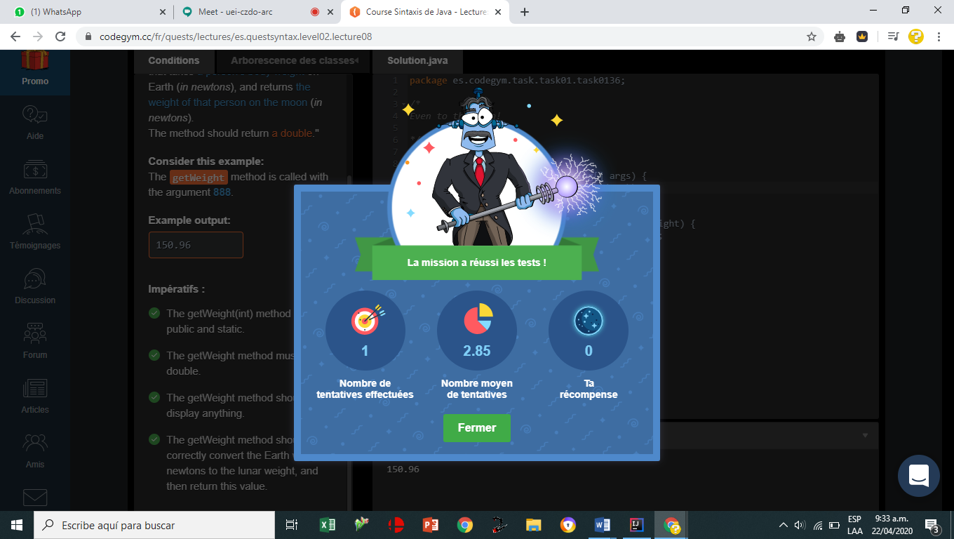

[N2_L8_E3](https://github.com/jaidernperez/Introduction_Programing/blob/master/CodeGym/N2_L8_E3.PNG)

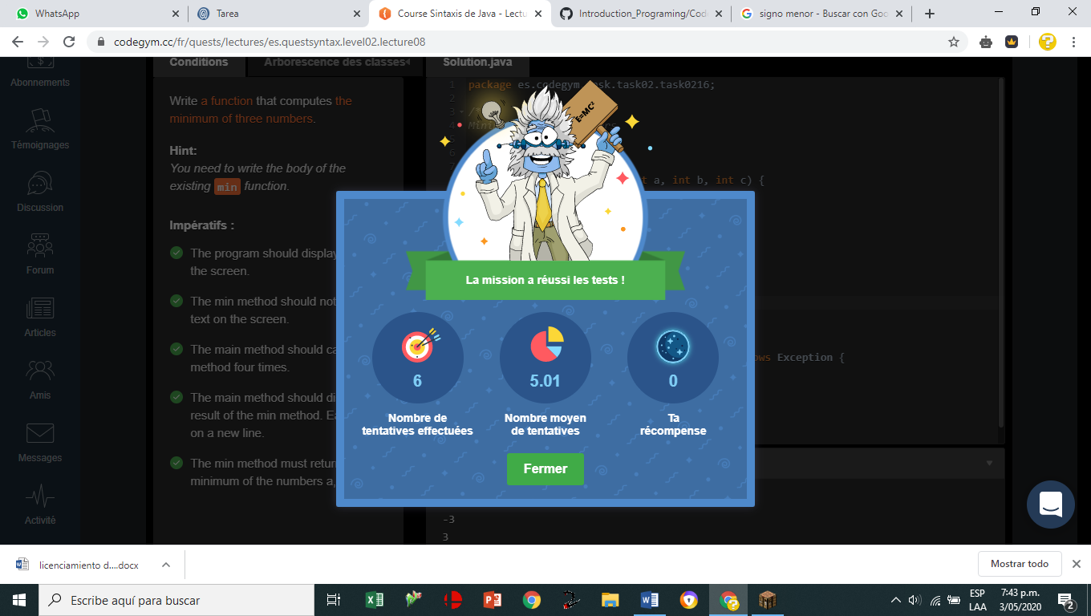

[N2_L8_E4](https://github.com/jaidernperez/Introduction_Programing/blob/master/CodeGym/N2_L8_E4.PNG)

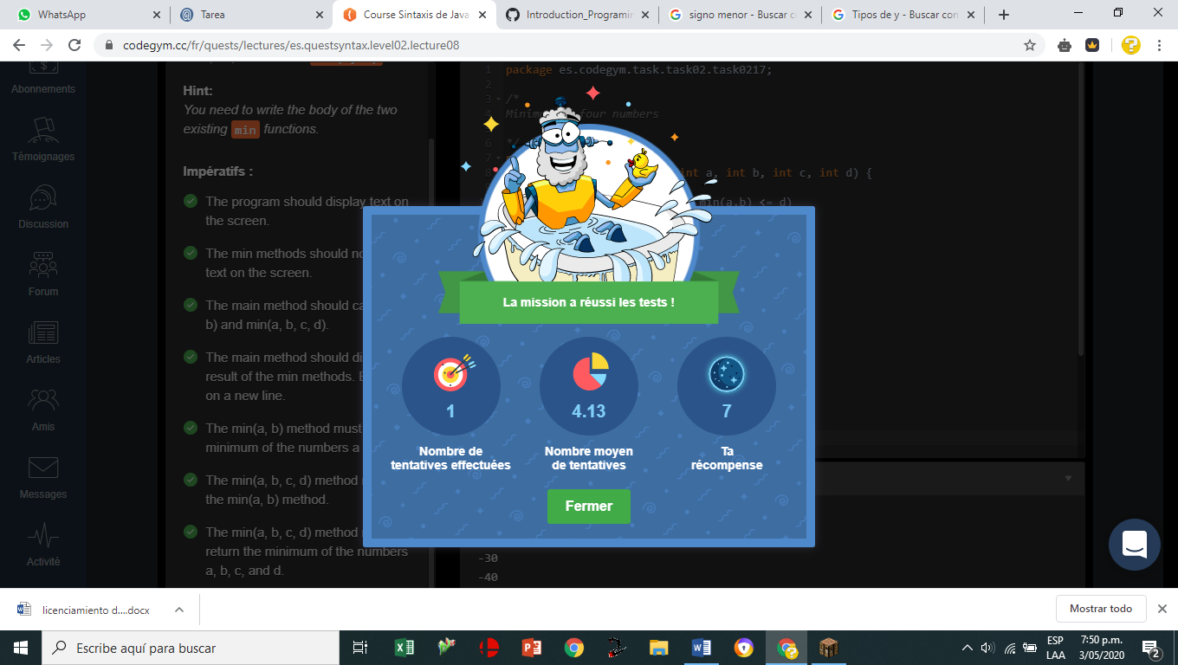

[N2_L8_E5](https://github.com/jaidernperez/Introduction_Programing/blob/master/CodeGym/N2_L8_E5.PNG)

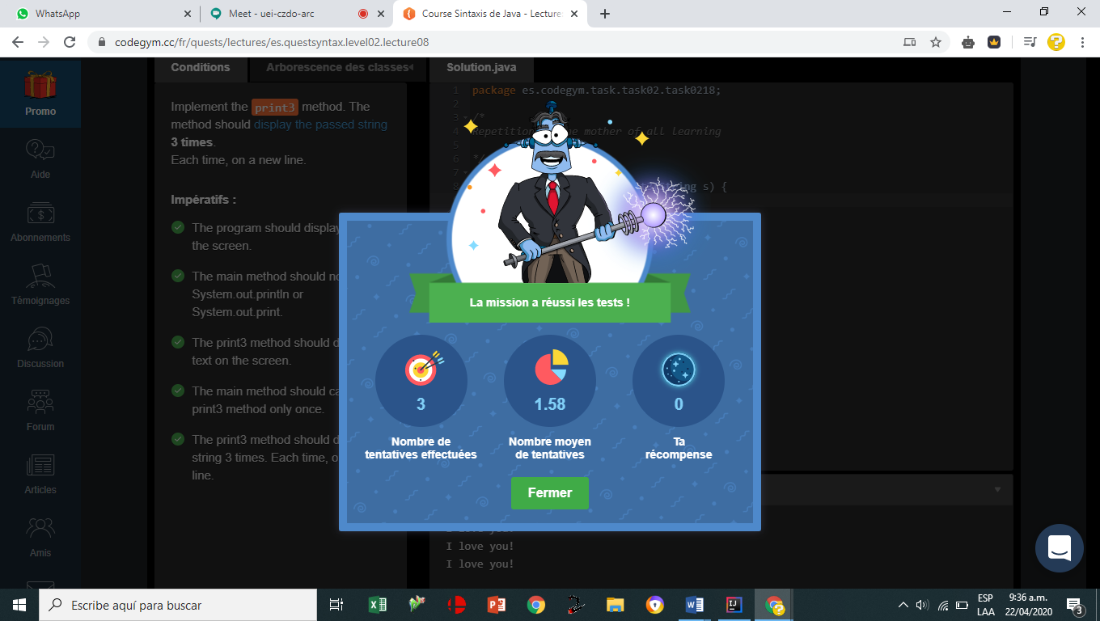

[N2_L8_E6](https://github.com/jaidernperez/Introduction_Programing/blob/master/CodeGym/N2_L8_E6.PNG)

